**SPATIAL DATA ANALYSIS (SDA)**

**AGBOOLA ISAAC OLUWATOMIWA**

**16th JUNE, 2024**

**TABLE OF CONTENTS**

**INTRODUCTION** 3

Question 1.1 Compare and contrast the advantages and limitations of different thematic map types. 4

Question 1.2 Identify and discuss the best methods to represent population density in a thematic map. 7

Question 1.3 Why should a choropleth map (almost) always show derived data? Provide a mapping example when the exception to this rule applies. 9

Question 1.4 Describe why you should classify some thematic map types but not others. 10

Question 1.5 What visual variables and symbol dimensionalities are used for each thematic map type and how do these differences impact their design and use? 11

Question 1.6 Create a choropleth map showing the unemployment rate within a selected country. Design an appropriate legend for the map. 14

Question 1.7 Create a proportional symbol map and a graduated symbol map for the same dataset and discuss the differences between the maps. Design an appropriate legend for both maps. 15

Question 1.8 Sketch a legend for each of the following thematic map types: choropleth, proportional symbol, graduated symbol, isoline, dot density, dasymetric, and flow 16

**CONCLUSION** 18

**REFERENCES** 19

# **INTRODUCTION**

The question given addresses the different kinds of concepts that are related to spatial data and Geographic Information System (GIS) models. It covers thematic map types, population density of the thematic map, symbol dimensionalities that are used the thematic map type, unemployment rate of the country, symbol, and diagram to represent the thematic map type. The explanation shows the understanding of the question and the practical application of the Geographic Information System.

# Question 1.1 Compare and contrast the advantages and limitations of different thematic map types.

Thematic maps, also referred to as subject maps or particular maps, are designed to illustrate specific topics or themes. Rather than providing a general overview of a geographic area, their primary purpose is to convey detailed information on population density, political boundaries, and vegetation (Daniel, 2023). These maps use symbols, colours, and patterns to represent the data effectively. Below, we outline various types of thematic maps commonly used, showcasing the diverse range of subjects covered in cartography, including Choropleth, Proportional symbol, Dot map, Isopleth, and Flow maps.

**CHOROPLETH MAPS**

These are maps where information is represented graphically using colour or pattern at the level of a geographic unit such as a census tract or country. Class intervals are a great way to make data values easier to read by dividing the data into three or more groups and using natural breaks or quantiles (Daleska, 2022).

**USES OF CHOROPLETH MAPS**

• It can be used for measuring Human Population Size and Density

• It can be used for Visualizing Revenue and Sales Volume Estimates

• It can Display Variation or Patterns across Locations

**ADVANTAGE OF CHOROPLETH MAPS**

• Choropleth maps visually group data into distinct colours, facilitating rapid comprehension of extensive datasets spanning multiple geographic regions.

• Creating a choropleth map is straightforward with tools like Maptive.

• They are highly effective for visualising variables into administrative units.

• Due to their widespread adoption, choropleth maps require minimal introduction or specialised expertise.

**DISADVANTAGES OF CHOROPLETH MAPS**

• Choropleth maps are most effective with provided information rather than specific numerical details.

* Choropleth maps have the potential to manipulate data and mislead viewers if misused, as the map's designer defines the data classes.
* Maps assume uniformity within enumeration areas despite potential fluctuations.
* Rapid changes in enumeration area boundaries can be misleading.

**DOT MAPS**

These maps use dots to represent the distribution of a commodity, with each dot corresponding to a specific value. They typically focus on spatial points rather than areas. An example of such a map is shown below.

**USES OF DOT MAPS**

* The large volumes of data are scattered across multiple locations.
* Analysing density and spatial patterns
* Using monochrome maps for publication or display

**ADVANTAGE OF DOT MAPS**

Dot density maps offer several advantages over other methods for depicting variation and geographical density. They are straightforward for map users to grasp and provide a clear representation of the data:

* They serve as an excellent alternative for individuals who favour black-and-white maps.
* Dot density maps often provide more accurate representations compared to other types like heat maps.

**DISADVANTAGE OF DOT MAPS**

Some software randomly positions dots within enumeration areas, often placing them far from the phenomena they represent. Additionally, selecting a single dot size that visually fits both high-density and low-density regions is difficult due to the range of data points. Contextual understanding is essential for interpreting dot density maps. Therefore, consideration of readability and boundary display adjustments is crucial when refining dot density maps.

**PROPORTIONAL SYMBOL MAPS**

Proportional symbol maps use symbols whose sizes are proportional to the values they represent. These maps are effective in illustrating the spatial distribution and magnitude of variables. One advantage of proportional symbol maps is their ability to depict relative magnitudes among variables and handle large datasets efficiently. However, if data scaling is inadequate or if the scale lacks a zero value, the accuracy of proportional symbol maps can be compromised, leading to potential misinterpretations (Jonathan, 2024).

**ISOLINE MAP**

Isopleth maps are one of two types of isorhythmic mapping; their values reflect a standard rate per unit area, derived directly from the data. Lines in this method represent areas of consistent values for a variable (Robert H., Russell H., & Tor H.). They are particularly effective for displaying the spatial distribution of continuous variables such as height, temperature, and precipitation.

# Question 1.2 Identify and discuss the best methods to represent population density in a thematic map.

**CHOROPLETH MAP**

These are a popular method for depicting population density on thematic maps. They use colour to represent visual variations in population across different geographic regions. This approach is both intuitive and effective for highlighting patterns in population distribution. However, inaccuracies can arise if the data is improperly scaled or the geographic areas are not uniform, potentially leading to misleading visual representations (Daleska, 2022).

**DOT MAP**

Using a dot map represents the second method. Dot maps, also known as point density maps, illustrate population distribution by placing dots on a grid to represent individual residents. This approach provides a clearer view of the frequency of less common events. Dot maps handle large datasets effortlessly and pinpoint exact locations accurately. However, displaying too many points of interest can make point maps difficult to interpret (A. John, 2013).

**PROPORTIONAL MAP**

Maps can represent population density using proportional symbols, such as circles or squares, to display visually the density of people in an area. This method efficiently manages large amounts of data and is adequate for illustrating population densities across different regions. However, inaccuracies in scale or incorrect symbol sizes can lead to misleading representations on proportional symbol maps.

**ISOLINE MAP**

The Isoline map presents a three-dimensional perspective. This method uses lines to illustrate areas with consistent population densities, effectively portraying patterns of population density across geographical regions and handling extensive datasets efficiently.

# Question 1.3 Why should a choropleth map (almost) always show derived data? Provide a mapping example when the exception to this rule applies.

Since, Choropleth maps typically display aggregated data at the level of geographic units like census tracts or counties, ensuring that derived data is consistently represented. This approach allows for accurate comparisons across the entire map, despite variations in the sizes of these units. For example, a choropleth map illustrating population density might indicate the density of a specific population in terms of inhabitants per square kilometre or square mile across various census tracts or counties. This method enhances the precision of comparing population density across the entire map, rather than solely comparing raw population statistics. Moreover, incorporating derived data on choropleth maps helps account for differences in the sizes of geographic units, facilitating more accurate data comparisons across the map.

# Question 1.4 Describe why you should classify some thematic map types but not others.

Classification is essential for specific types of thematic maps, such as choropleth and isorhythmic maps, because they portray aggregated data at the level of geographic units, such as census tracts or counties. Creating data into meaningful groups through classification simplifies analysis and comparison. It ensures consistent comparisons across the entire map by similarity differences in the sizes of geographic units. For instance, when creating a choropleth map, data is classified by grouping census tracts or counties into distinct population density categories. This method enhances the accuracy of comparing population density across the entire map, rather than merely comparing raw population statistics.

# Question 1.5 What visual variables and symbol dimensionalities are used for each thematic map type and how do these differences impact their design and use?

**CHOROPLETH MAPS**

They are a type of statistical visualisation. In these maps, data is colour- or pattern-coded to show aggregated findings at the level of a geographic area, such as a census tract or country. In most cases, colour is appropriate as the visual variable. The symbol’s dimensionality is area, meaning that the size of the geographic unit is held constant. The colour or pattern varies to convey the data. The number of classes, the colour scheme, and how the data is classified all influence choropleth map creation and interpretation. Lighter colours typically represent smaller numbers, while darker colours represent larger numbers when displaying quantitative data. Yet, if the data is not scaled correctly or the regions lack uniformity, the resulting choropleth map may be misleading.

**PROPORTIONAL MAPS**

Symbols such as circles and squares, among others, are appropriate to show the absolute value of a variable at specific points on a map with appropriate proportional symbols. Visual factors such as position, size, and colour are appropriate. To create a proportional symbol map, place a symbol at the variable's location and adjust its size accordingly. The capacity of each image is often chosen so that its area reflects the variable's magnitude, though alternative methods like classifying symbols by size ("small," "medium," "large") are also appropriate. Location, size, and colour can visually convey the relative magnitude of a variable across an area, but this can be misleading if the data is not scaled appropriately or if symbols are not correctly proportioned.

**DOT MAPS**

Dot maps, also known as dot density maps, depict the prevalence of a variable across a specific area using individual dots. Positional visual cues are created by placing dots where the variable is present. On dot maps, the occurrence rate is indicated by the number of dots, rather than the size of a symbol as seen in proportional maps (GIS Geography, 2018). Appropriate position and quantity enable the visualisation of variable distribution throughout a region and are particularly effective for illustrating unusual events. However, excessive dot density on the map can hinder readability and interpretation.

**ISOPLETH MAPS**

Isopleth maps, which are a type of contour map, employ lines to indicate regions where a variable maintains consistent values. Since isopleths are one-dimensional, their location is the sole visual variable that can be adjusted. These maps create the spatial distribution of a variable by connecting locations that share the same value. However, if the lines on an isopleth map are too closely spaced, it can impede readability and interpretation. Flow maps, commonly called streamlined maps, illustrate the movement of people, goods, or information between different geographic areas. The visual variables used are position and orientation, and the symbols are flat. Creating a flow map involves drawing lines from origin to destination on a map and varying the line thickness to indicate the magnitude of the variable in question. While location and direction effectively represent the flow's direction and strength, maps with excessive or closely spaced lines can be challenging to interpret.

In summary, the design and functionality of different types of thematic maps depend on various visual factors and symbol dimensions. Distinct data points and symbols are given priority based on the specific data and research objectives. Different combinations are best suited for various types of information and analyses.

# Question 1.6 Create a choropleth map showing the unemployment rate within a selected country. Design an appropriate legend for the map.

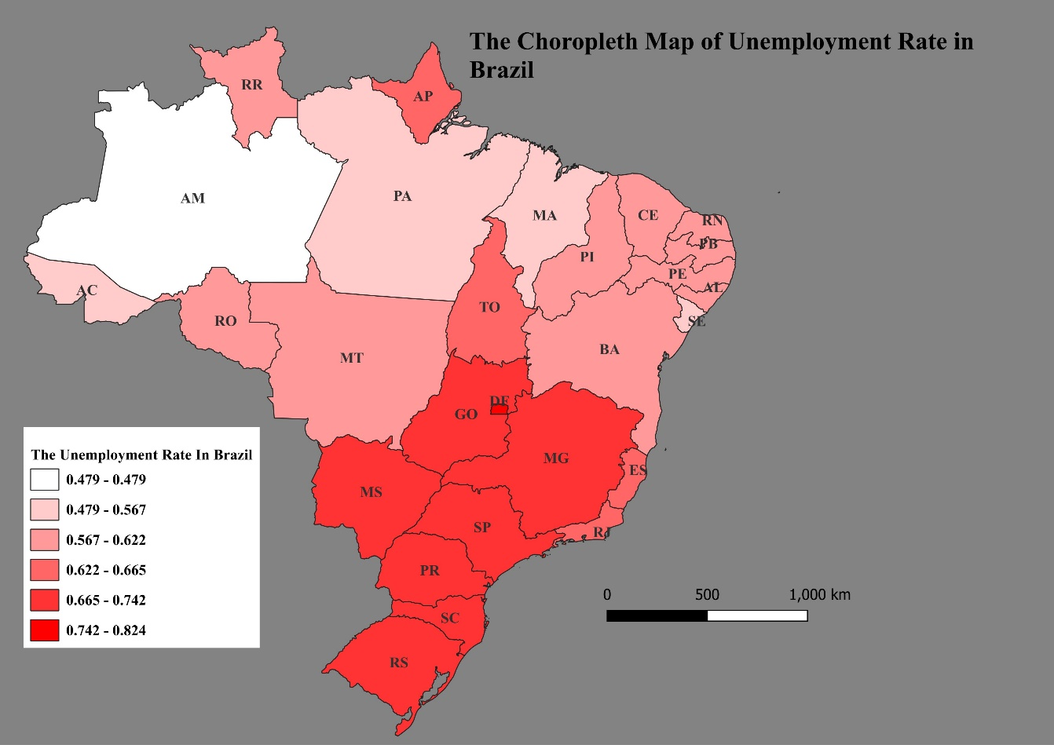

**Figure 1: The Unemployment rate of Brazil**

# Question 1.7 Create a proportional symbol map and a graduated symbol map for the same dataset and discuss the differences between the maps. Design an appropriate legend for both maps.

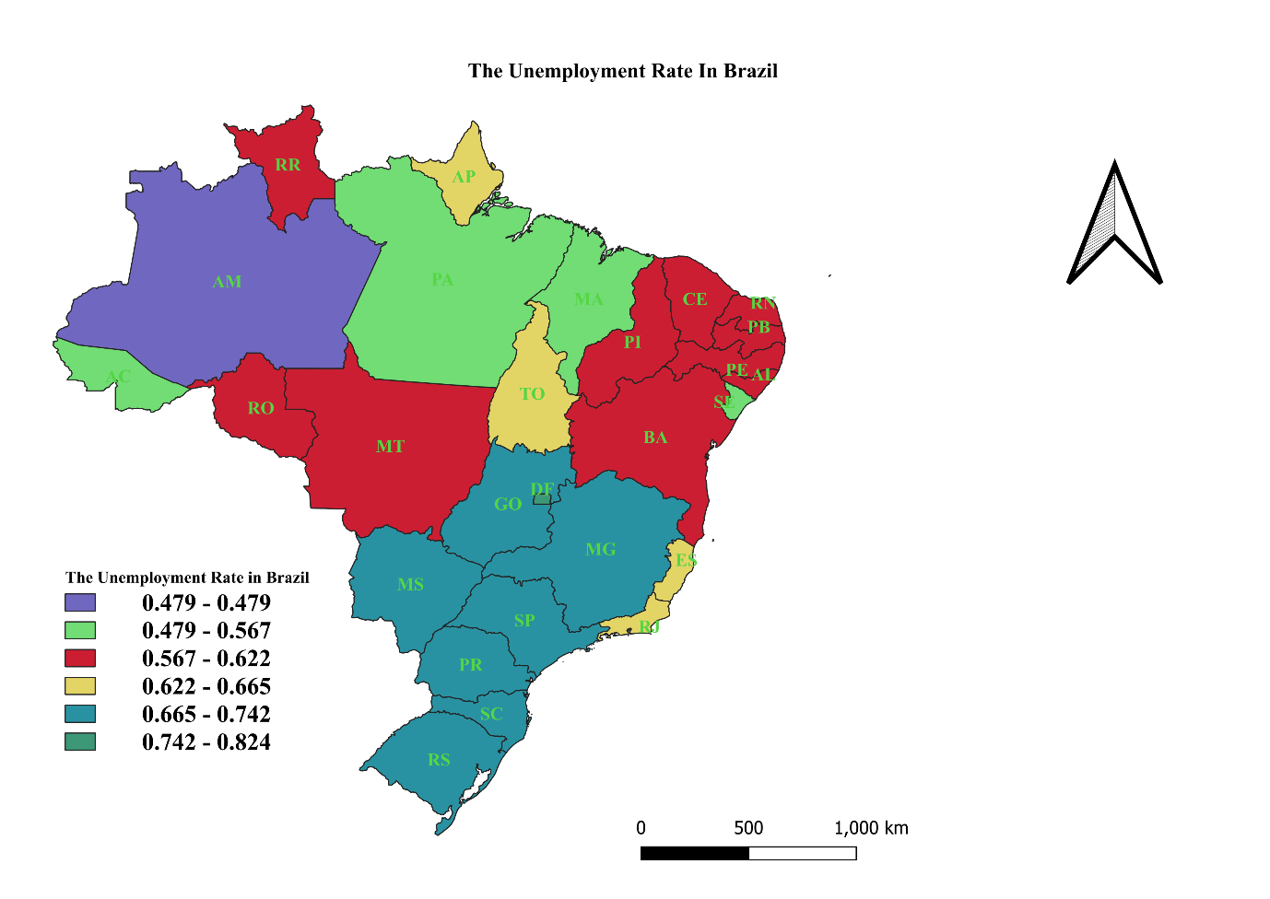

**Figure 2: The Unemployment rate of Brazil using the graduated data**

# Question 1.8 Sketch a legend for each of the following thematic map types: choropleth, proportional symbol, graduated symbol, isoline, dot density, dasymetric, and flow

1. Choropleth Map

|  |
| --- |
|  |

10 – 20%

|  |
| --- |
|  |

20 – 30%

|  |
| --- |
|  |

30 – 40%

|  |
| --- |
|  |

40 – 50%

1. Graduated Map

|  |
| --- |
|  |

|  |
| --- |
|  |

10 – 20 %

20 – 30%

|  |
| --- |
|  |

30 – 40%

1. Proportional Symbol

|  |
| --- |
|  |

10%

|  |
| --- |
|  |

20%

|  |
| --- |
|  |

30%

|  |
| --- |
|  |

40 %

1. Dot Map

|  |
| --- |
| . |

10,000

|  |
| --- |
| ….. |

20,000

|  |
| --- |
| …….  …… |

30,0000

# **CONCLUSION**

Lastly, we have understood the knowledge and understanding of spatial data and Geographic Information models (GIS) by showing the ability to answer and identify, explain and discuss thematic map type, advantages, limitations/disadvantages, uses, and unemployment rate of the country which is Brazil, the diagram and symbol to demonstrate the thematic map type in Geographic Information System models (GIS). This was done by answering the question correctly in Geographic Information Systems (GIS) and spatial analysis.

# **REFERENCES**

A. John, K. (2013, March 14). Dottiing the Map, Revisted. *36*(2), 165 - 182. Retrieved from https://doi.org/10.1559/152304009788188754

Daleska, P. (2022, May 17). Choropleth Map: Definition, Uses & Creation Guide | Venngage.

Daniel, O. (2023, March 6). What is a thematic Map.

Jonathan, S. (2024, February 7). Bivariate Proportional Symbol Maps, art 1: An Introduction. *IPUMS Research Scientist, NHGIS Project Manager*.

Robert H., W., Russell H., C., & Tor H., N. (n.d.). Preparation and use of Isopleth maps of landslide deposits | USGS. Retrieved from https://doi.org/10.1130/0091-7613(1974)2<483:PAUOIM>2.0.CO;2